DengFeng Qiao Yi He MingYi Wang

1.

a. Humans, Mammals, Monkeys, Primates

1. Mammals

- Primates

- Monkeys

- Humans

b. Linux, Oracle, Software System, Operating System, Database Management System, MySQL, Windows, Chrome

1. Software System

- Operating System

- Linux

-Windows

- Database Management System

- Oracle

- MySQL

- Applications

- Chrome

2.

a. Entity

Definition: An entity is an object, thing, concept, or event in the real world that can be distinctly identified. Each entity has specific characteristics or attributes. For example, in a school database, a “Student” can be an entity.

b. Entity Type

Definition: An entity type is a collection of entities that share common attributes. It defines the name of the entity and its attributes. For example, “Student” is an entity type that may include attributes like Student ID, Name, and Age.

c. Entity Instance

Definition: An entity instance is a specific occurrence of an entity type, with concrete attribute values. For example, if “Student” is an entity type, then “John Doe” is an instance of the “Student” entity type.

d. Optional

Definition: In the ER model, an attribute or relationship is optional if an entity may not include that attribute or may not participate in that relationship. For example, a “Phone Number” attribute might be optional for an “Employee” entity, meaning employees can have no phone number recorded.

e. Mandatory

Definition: Mandatory means that an entity must include a particular attribute or must participate in a specific relationship.

f. Cardinality

Definition: Cardinality specifies the numerical constraints on the relationships between entities. It defines how many instances of one entity can or must be associated with instances of another entity.

3.

Definition of Data Model

A data model is an abstract representation that organizes and defines how data is stored, connected, and manipulated within a database system. It provides a structured framework to ensure that data is logically and physically consistent.

Importance of Data Modeling

3.1 Improves Data Consistency and Accuracy:

Data modeling clearly defines the structure, rules, and relationships within a database, which helps in reducing redundancy and ensuring accurate data storage.

3.2 Facilitates Communication and Understanding:

A well-constructed data model serves as a visual tool for communication among stakeholders, making it easier for teams to understand and agree on data requirements and usage.

3.3 Enhances Database Performance and Scalability:

Proper data modeling optimizes database design, ensuring the system can efficiently handle large data volumes and complex queries, and can easily scale as requirements grow.

4.

4.1

Branches and Departments: Each branch has multiple departments, and each department belongs to one branch.

Departments and Employees: Departments consist of employees, with each employee belonging to one department.

Management: Each department is managed by one employee, and an employee can manage only one department.

Employees and Projects: Employees can participate in multiple projects, and each project must involve at least one employee.

4.2

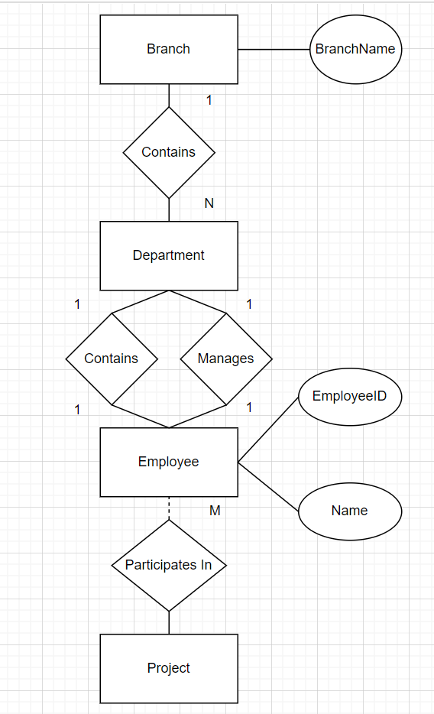

5

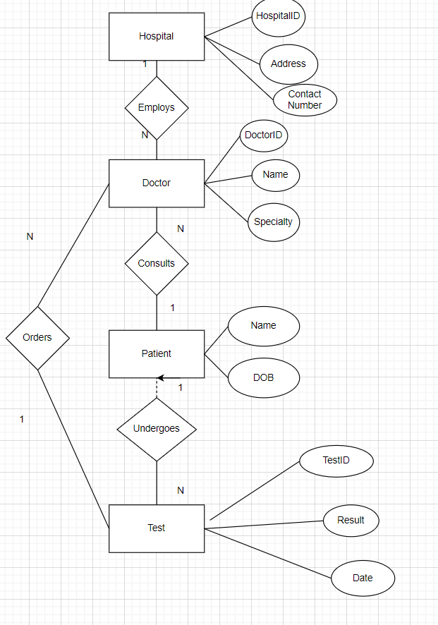

6.

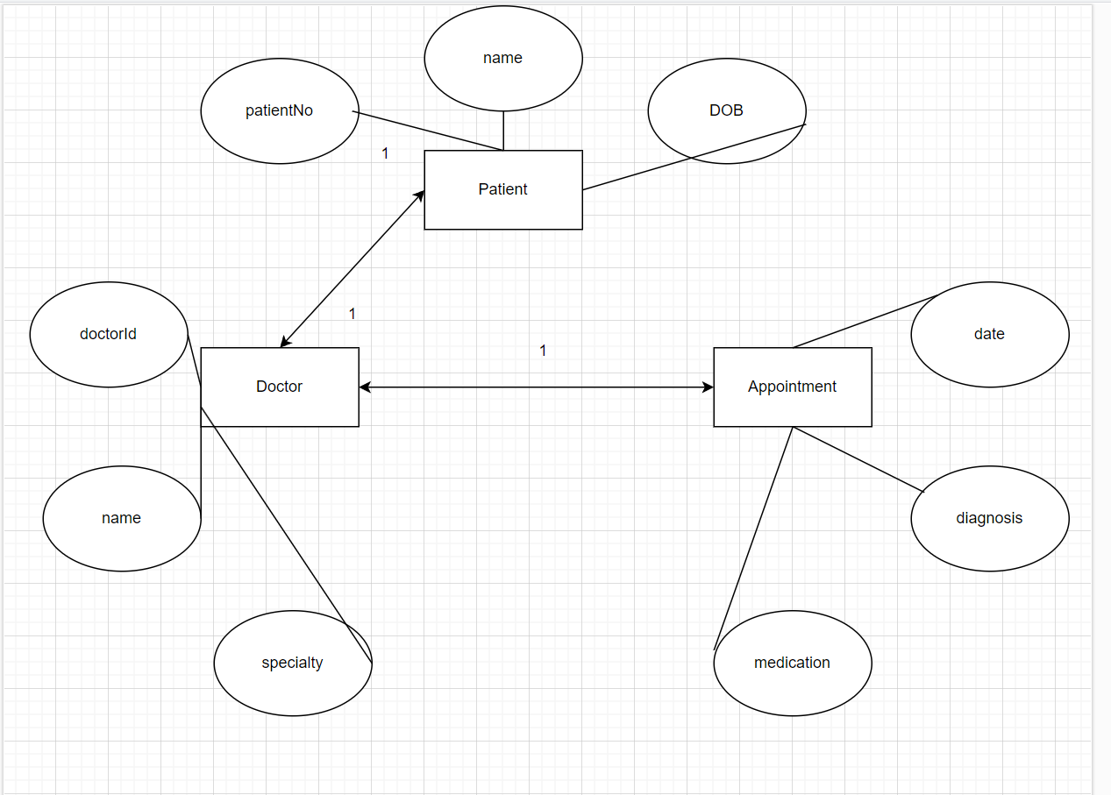

7.

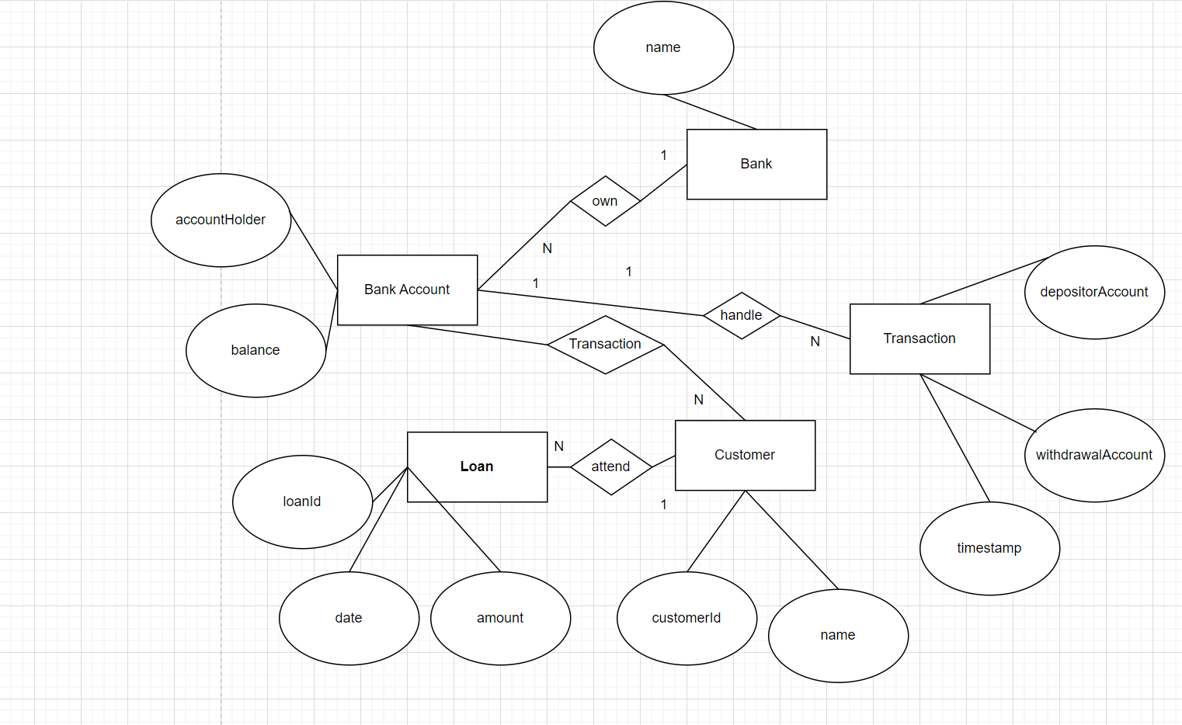

8.